Contents

1. Initial ‘HALEY’ Survey 1

1.1 Survey Setup 1

1.2 User Information Management 1

1.3 Geographical Area Covered 1

1.4 Results 1

1.4.1 Age Group- 1

1.4.2 Number of Dependents- 2

1.4.3 Living Arrangements- 2

1.4.4 GP appointments- 3

1.4.5 Medical data management- 3

1.4.6 Medical Document management- 3

1.4.7 Need of Application- 4

1.4.8 Likely to Use- 4

1.4.9 Likely to Replace- 4

1.4.10 Likely to Recommend- 4

1.5 Analysis 5

1.6 Conclusion 5

2. Prototype Survey 6

2.1 Survey Setup 6

2.2 User Information Management 6

2.3 Geographical Area Covered 6

2.4 Results 6

2.4.1 Age Group- 6

2.4.2 Visual Appeal- 7

2.4.3 Diagnose button- 7

2.4.4 Navigation- 7

2.4.5 Overall Design- 8

2.4.6 Layout- 8

2.4.7 Suggestions- 9

2.5 Analysis 9

2.6 Conclusion 9

# 1. Initial ‘HALEY’ Survey

As a part of initial analysis for the project ‘Haley’ we have designed a survey that caters to our need. This survey takes in information from the user and then analysis the general opinion of the population. This was hosted on google forms link- <https://docs.google.com/forms/d/e/1FAIpQLScO_ohMfNhvg4kfmldC7UsZIGNTVo0726xXm7qQ4HOEMoEAGQ/viewform>

## 1.1 Survey Setup

The survey has a total of 10 questions and is divided into 3 parts-

1. Personal details- The survey takes in general details like age, no. of dependents, and living situation. For each question, the survey gives the user a range of possible answers from which any one can be selected.
2. Health related details- The survey takes more general information like whether the user manage their health, are they in charge of their documents and do they have it handy, and lastly, how easy it is for the user to get professional help.
3. Project related questions- The survey gives a small introduction to our application and then ask users for their opinion about whether they will be happy to use it, whether they feel it is something they need or not.

## 1.2 User Information Management

We have taken care that the users are anonymous, and we do not take in any sensitive data, also most of the personal data questions used options like range for age and yes and no answers for the rest.

## 1.3 Geographical Area Covered

We got good response for the survey. Approximately 150 people took part in it across various countries ranging from Ireland, India, Pakistan, UK, Argentina, and France.

## 1.4 Results

### 1.4.1 Age Group-

We gave options for age from 18 and above. The general response of the population shows that most of the users were between the age 18 to 32. The below pie chart shows more about the distribution of ages across the initial sample population-

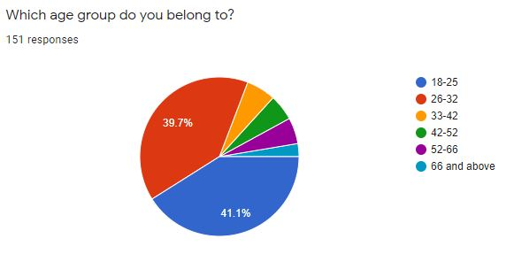

*Figure 1- Age Group distribution*

### 1.4.2 Number of Dependents-

This was an optional field so out 150 total responses we got 133 responses on this question 70% of the total users said they have 0 dependents and all the other 6 answers got 30 percentages.

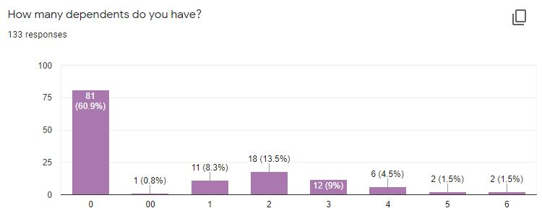

*Figure 2- No. of Dependents Distribution*

### 1.4.3 Living Arrangements-

This had 3 options for this question yes, no, and maybe. 43.9% people live by themselves.

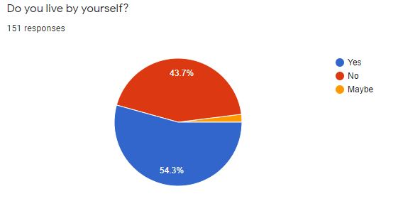

*Figure 3- Living Arrangements Distribution*

### 1.4.4 GP appointments-

This question determined how long a person needs to wait to get an appointment with their GP. It has options like same, day, within 1-2 days or more. The distribution was somewhat equal.

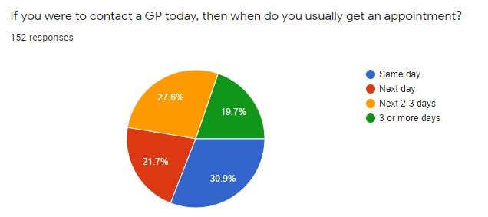

*Figure 4- GP appointment distribution*

### 1.4.5 Medical data management-

This question has three options yes, no, or maybe. This question determines whether a person has control over their medica data or not. The distribution was as follows-

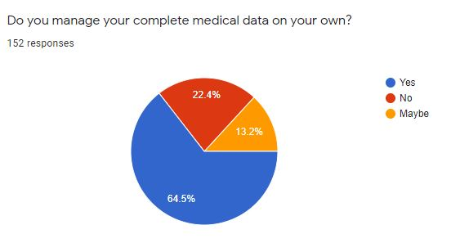

*Figure 5- Medical Data Distribution*

### 1.4.6 Medical Document management-

This question has three options yes, no, or maybe. This question determines whether a person has their medica data on go or not. The distribution was as follows-

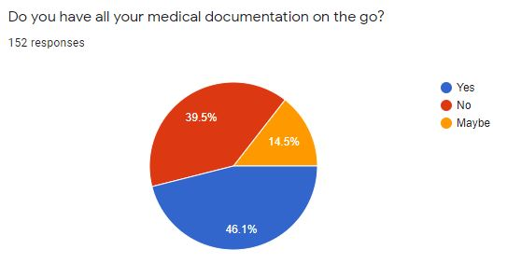

Figure 6- Medical Documentation Management.

### 1.4.7 Need of Application-

This question has three options yes, no, or maybe. This question determines whether a person thing there is a need for the application is or not. The distribution was as follows-

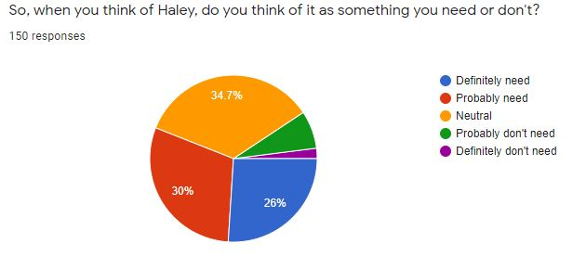

Figure 7- Application Need Distribution.

### 1.4.8 Likely to Use-

This question has three options yes, no, or maybe. This question determines whether a person will use the application is or not. The distribution was as follows-

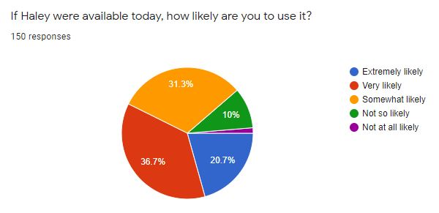

Figure 8- Application Likely to Use Distribution.

### 1.4.9 Likely to Replace-

This question has three options yes, no, or maybe. This question determines whether a person is likely to replace their current application with our application is or not. The distribution was as follows-

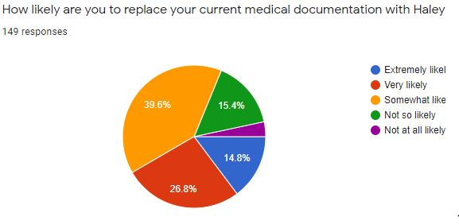  
Figure 9- Likely to Replace Distribution

### 1.4.10 Likely to Recommend-

This question has three options yes, no, or maybe. This question determines whether a person is likely to recommend our application to their friends or not. The distribution was as follows-

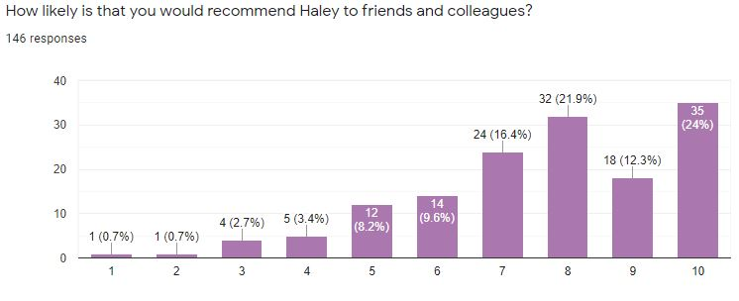

Figure 10- Likely to Recommend Distribution.

## 1.5 Analysis

From the above results we were able to determine that firstly, the users of our application have an age range primarily between 18 to 36, but the users above that age may also use the application.

Secondly, out of all the users almost 30 percent of them our parents who would appreciate the extra parental functionality provided by the application.

Thirdly, the people who live alone are more vulnerable to having no one to depend on in the time of need. The community functionality is a big boon to these people, which is approximately 43.7 percent of the whole population.

Fourthly, not all users are able to get professional help within 24 hrs, hence the functionality of home remedies will be helpful to these users till they are able to get professional help which is 57 percent of the whole population.

Fifthly, 35 percent of the users do not manage their medical data and 54 percent of users do not have their medical data on go. The functionality of medical history storage will help these users.

Sixthly, 56 percent of the users feel there is a need of an application like Haley, and 87 percent users feel that they will give the application a try if available.

Seventhly, 51.6 percent users are not happy with their current application and are likely to replace the application with ours.

Lastly, more than 60 percent of the users liked our application idea and will recommend their family, friends, and colleagues to try out our application based on the initial idea.

## 1.6 Conclusion

The analysis shows that there is a need of an application like ‘Haley’ in the current market and the initial survey suggest that a lot of users will try out the application just based on the features available to them.

# 2. Prototype Survey

Another survey was conducted to get an idea about the users’ thoughts on the initial prototypes. The survey does not take in any user details except for a generic age group hence, there is not much GDPR implications of this survey.

https://docs.google.com/forms/d/1BLKxpHJPceZgXhOAgWNroVtGy2WPzwOI5akVIi2yveI/edit?ts=5f8f0815&gxids=7757#responses

## 2.1 Survey Setup

The survey has a total of 8 fields of which 7 are questions and 1 is generic text field. The survey questions are divided into 3 parts-

1. Visual- The survey in general wants to gauge the first impression of the users when they look at the screens.
2. Functional- The survey wants to know how the users’ found the location of buttons and navigation through pages and functionality to be.
3. Thoughts- The survey asks the users about what the team can do to improve the designs to make it more appealing for them.

## 2.2 User Information Management

We have taken care that the users are anonymous, and we do not take in any sensitive data, also most of the personal data questions used options like range for age.

## 2.3 Geographical Area Covered

We got good response for the survey. Approximately 15 people took part in it across various countries ranging from Ireland, India, Pakistan.

## 2.4 Results

### 2.4.1 Age Group-

We gave options for age from 18 and above. The general response of the population shows that most of the users were between the age 18 to 32. The below pie chart shows more about the distribution of ages across the initial sample population-

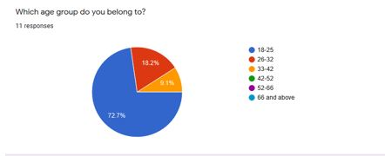

Figure 11- Age Distribution

### 2.4.2 Visual Appeal-

The survey asks a yes or no question the distribution is as follows-

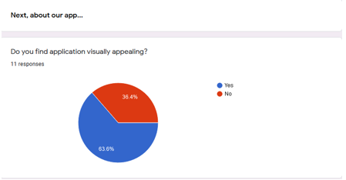

Figure 12- Visual Appeal Distribution.

### 2.4.3 Diagnose button-

The survey asks a rating question with a Likert scale of 1 to 10 where 1 is the lowest and 10 the highest the distribution is as follows-

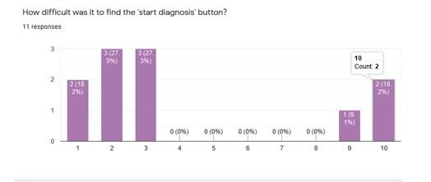

Figure 12- Diagnose Button Distribution.

### 2.4.4 Navigation-

The survey asks radio button question where the user has to select 1 of the 5 options available the distribution is as follows-

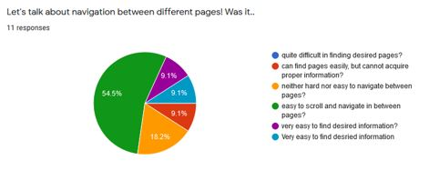

Figure 12- Diagnose Button Distribution.

### 2.4.5 Overall Design-

The survey asks a rating question with a Likert scale of 1 to 10 where 1 is the lowest and 10 the highest the distribution is as follows-

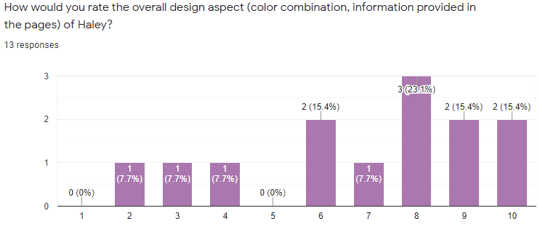

Figure 13- Overall Design Distribution.

### 2.4.6 Layout-

The survey asks a yes or no question the distribution is as follows-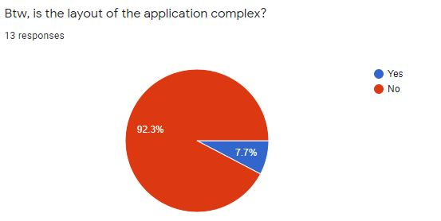

Figure 14- Layout Distribution

### 2.4.7 Suggestions-

The survey provides a text box for the users to type their suggestions the result is as follows-

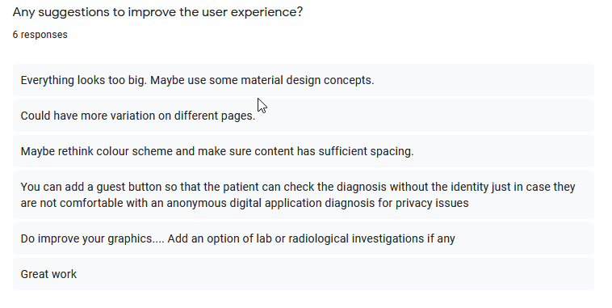

Figure 15- Suggestions.

## 2.5 Analysis

From the above results we were able to determine that firstly, the users of our application have an age range primarily between 18 to 36, but the users above that age may also use the application.

Secondly, our application is visually appealing to 60% of the users but 40% were not really into it.

Thirdly, 80% of the users found the buttons on the prototype easily and 20% had to look for it, a little more work is needed to make button easily visible.

Fourthly, we got mixed responses with regards to the navigation through the pages it needs a lot of work.

Fifthly, 90% of the user found the overall design nice, we have to improve it to make it more appealing for all.

Sixthly, the users found our application layout easy, hence not much needs to be changed in it.

Lastly, we got some interesting feedback which we will take into consideration while refining the prototypes and building the actual model.

## 2.6 Conclusion

The analysis shows that a lot of work is needed to be done by the team to make the application more visually appealing and interesting for the users. The team is working towards this goal.